|  |
| --- |
| **American International University- Bangladesh** |
| OOP1 Final Term Project Report Tutor Management System  Project Submitted By:  17-33115-1 :: Rafi, Quazi Ghulam  17-33105-1 :: Mohammed Noman  17-34297-1 :: Hasan MD Zahid |

**Group No : A07**

**Course : Object Oriented Programming-1 (JAVA)**

**Section : A**

**Date : 18-12-2018**

**Introduction:**

Students when looking for a private tutor often face difficulties to find appropriate private teachers meeting their criteria and vice versa. Our desktop application ‘Tutor Management System’ resolves this issue by creating a bridge between private tutors and students.

**User Category:**

There are 3 types of Users here. They are:

* Admin
* Students
* Teachers

**Feature List:**

In this project the “Admin” has the following features:

* Can **View** information of all teachers
* Can **Delete** any teacher
* Can **View** information of all students
* Can **Delete** any student
* Can **Assign** teachers to students (Many to Many relation possible)
* Can **Unassign** the assigned teachers to students.
* Can **Register** a new teacher into the system

In this project the “Students” has the following features:

* Can **View** the information of the teachers assigned to that student (A student can have multiple teachers)
* Can **Rate** the teachers assigned to that student
* Can **Update** his or her own information
* Can **View** the information of the available teachers
* If wanted can **View** the information of only the rated teachers
* Can **View** his or her own information
* Can **Register** from the login page

In this project the “Teachers” has the following features:

* Can **View** the information of the students assigned to that techer (A teacher can have multiple students)
* Can **Update** his or her own information
* Can **Choose** the medium of communication with the students (By mail or by phone or both)
* Can **View** the information of the available students
* If wanted can **View** the information of only the students interested in his or her own subject
* Can **View** his or her own information

**GUI Description:**

Using the login page (Fig 1) all the users Login into the system. They must insert their ID and password in the relative fields (JTextField) and can press ‘Login’ button to enter the system. ‘Exit’ is to be used to exit the system and ‘Register’ to be used to go to the students’ registration page.

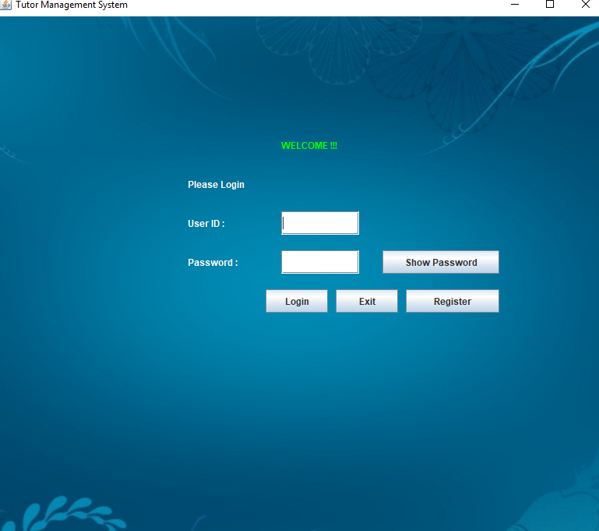

***Fig 1: Login page***

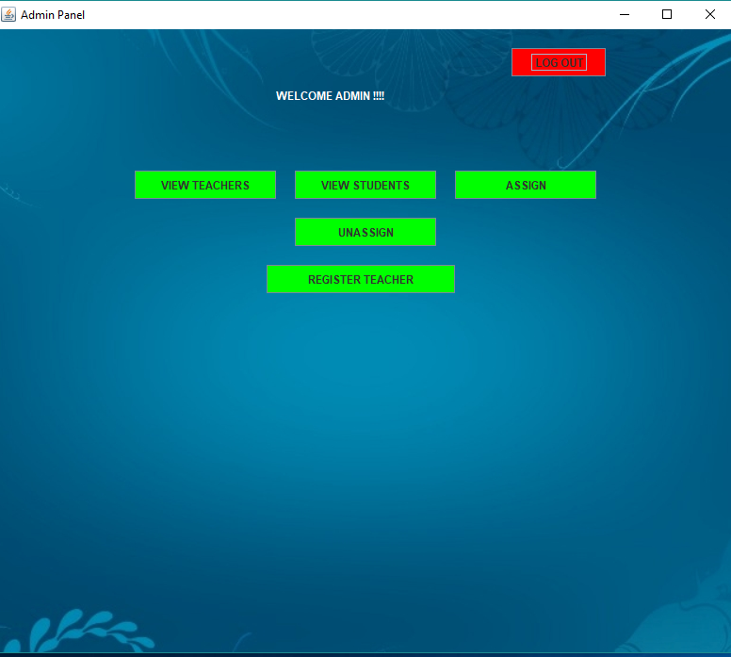

***Fig 2: Typical Homepage of the users***

Fig 2 represents a typical homepage of the users. The Buttons are to be clicked or entered to perform the relative described tasks.

Through this GUI (Fig 3) the admin can view the information of all the teachers who are registered into the system. Below the table the Text Field is to be used to search the ID of the teacher to be deleted and then the Delete button is to be clicked to delete the teacher from the system. After deletion the GUI refreshes the system would no longer show the deleted teacher’s information.

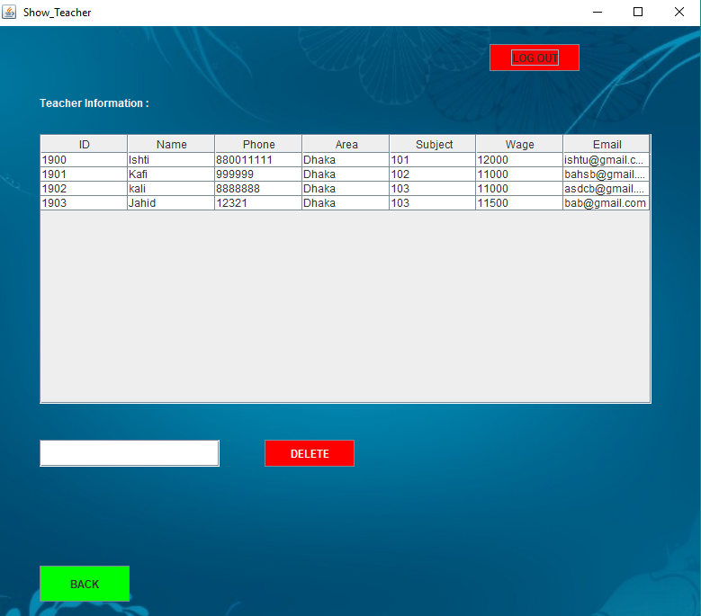

***Fig 3: Show Teacher’s Information Page***

**Database Table Description:**

Login table:

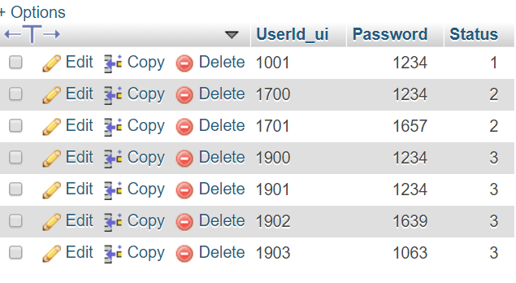

Student table:

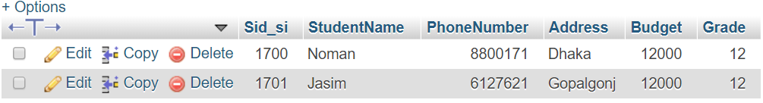

Teacher table:

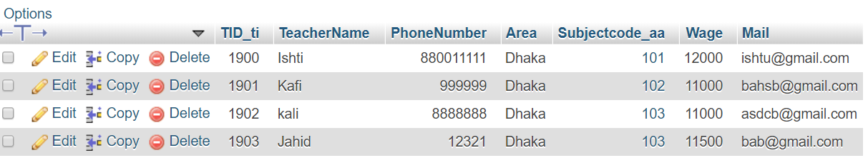

Subject table:

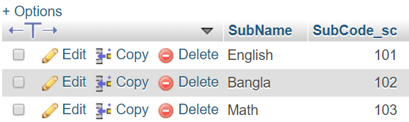

Rating table: Preference table:

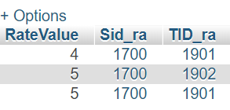 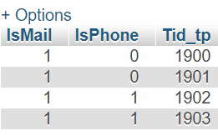

Choice table: Assignedto table:

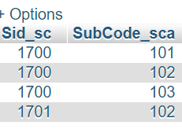 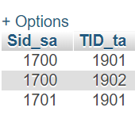

**Impact of this Project:**

Due to this project, the private tutors and students would be able to find, communicate and interact with each other more easily. Today correspondence of want is difficult to satisfy between teachers and students. If they register into the system developed in this project they would be able to locate each other more easily and hence both the teachers and students would be benefitted as the students can find the teachers quickly and the teacher can find a better and more suitable job quickly.

**Limitations and Possible Future Improvements:**

* Our system does not validate and verify any user input.
* The system can handle up to 200 students
* A major error of this system is that, while developing the Phone Number type in the database was set to integer which should be changed to String (Varchar) or a number (for example 8800) should be fixed in the beginning of the fields of the input to resolve the error. Otherwise the starting ‘0’ of the phone number gets ignored by the compiler.